Author: Matthew Eagleman
Date Created: 9/29/2025
Game Design Doc
Table of Contents
- Game Overview
- Gameplay and Mechanics
- Story and Narrative
- Art and Assets
- Audio and Music
- Technical and Production Details
- Meeting Notes

- Game Overview
Title: Husk
Genre: Horror
Description:
A new, confusing condition has taken hold of the world, turning everybody unfortunate enough to be exposed to it into a husk of their former self. They go about their day to day tasks, but there isn’t anybody there. Their movements are uncoordinated and lacking any conscious thought. They act on muscle memory alone, leading to potentially dangerous situations for them, and the people around them. You are a 10 year old boy, left in charge of your 4 year old younger brother while your parents are away on a date. Tragically, it seems your father has fallen victim to this illness, and he
- Gameplay and Mechanics
All inputs from the player will be using unity’s input system package. Read about it here. All non player characters will move using A* pathfinding. Whether we will use a prebuilt one or just make one on our own is up to debate.
2.1 Movement:
Player: Movement.cs
The movement is that of a top down rpg like zelda. Up, down, left, and right.
Walking Input: Arrow Keys/WASD.
Running Input: Shift
When running, the younger brother hops on your back, which is cute, and avoids annoyingly having to wait for him.
Younger Brother: BrotherMovement.cs
Walking: The younger brother follows after the older brother automatically using the A* pathfinding algorithm.
Running: same as walking, but slightly faster
Piggyback: position is the same as brother
Husk Father: FatherMovement.cs
The Father will have different movement patterns depending on what he is doing.
Idle: The father will walk to different preset locations to work on random tasks (playing guitar, washing dishes, etc.) The player will be able to hear him working on these things (dishes breaking, guitar twanging, etc). He will navigate to the location of each task using A* pathfinding, and what he is doing will be chosen randomly.
Searching: If the player makes too much noise, the dad will hear it. His footsteps will get faster and louder as he runs towards the location of the noise using
Pursuing: If the player is within Terry's sight he will start sprinting towards the players location
Stunned: Terry will stop for a second getting his bearings, before resuming one of the other states
Dragging: Terry will drag the younger son

2.2 Player Actions:
Piggyback
Put your little brother on your back and carry him. You can’t carry your brother and 2 handed tools at the same time.
Input: R / F
Open Inventory
Input: E / X
Interact
Input: C / Left Click / Enter
Hiding
Interact with a hiding spot to hide there

2.3 Inventory:
The inventory will have 16 slots for you to put small enough items into your pockets, 8 for each pocket on either side. Player must keep
Realistic inventory capacity:
The player can hold many small items, but only 1 or two larger items like a baseball bat or fire extinguisher. The player will likely have to run to grab a weapon when father is after him and his brother.

2.4 Pausing
Input: Escape key
2.5 Items:
Items will be Large or Small
You can only hold 1 large item in your hands at a time
Small items will have a weight associated with them
Baseball Bat
Abilities:
- Breaks windows
- Stun Terry
Cons:
- Makes a lot of noise, attracts dad
Crowbar
Essentially an upgrade to the baseball bat
Abilities:
- Same as bat
- Can pry things open (vents, doors, etc)
Cons:
- Same as bat
Sling Shot
Abilities:
- Stuns terry
- Makes noise that Terry will walk over to check out.
Climbing shoes
Abilities:
- Allows you to climb up the Laundry shute
Cons:
- Makes walking/running louder

- Story and Narrative
3.1 Narrative
start:
The game starts off completely normal. The dad is making dinner, the mom is playing go fish with the little brother, and you are free to walk around the house and talk with the parents, and look at stuff.
Pre bad stuff:
The parents leave you alone with your little brother, and you have a little more time to roam around. It will shortly start raining. You put your brother to bed, and wander around for a bit longer. Then the power goes out.
Bad stuff:
The father crashes in through a window and the game begins.
3.2 Setting
Season: Summer
Time: 6:00pm - 4:00am
Place: Out in the countryside, Wyoming. The cabin is too far away for the boys to walk anywhere without getting lost. Most of the game will take place in the house, or in the front or back yard. You can walk down the road a bit, but this will result in a game over.
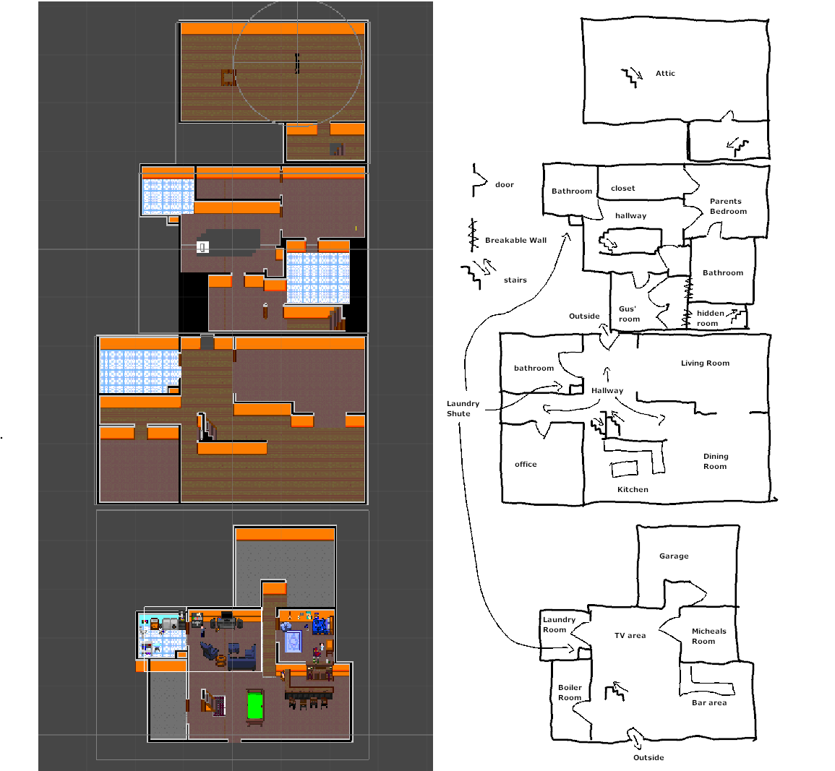
Fig.1: The full house as of 1/5/2026
3.3 Angela, the mom
Age: 36
A bubbly, energetic woman. She also likes doing sports like skiing or kayaking, and works as a photographer. She is a little busier than Terry, but still loves hanging out with the kids, and does so whenever she can.
3.4 Terry, the dad
Age: 35
Height: 6’
The dad is a super sweet, good, nurturing father. He likes skiing, and is very involved with the boys. He pretty often will be found playing with them, whether video games, catch, boating, etc. He's a little clumsy, and irresponsible.
Maybe space related job
Maybe geology related job

Note: put brother in freezer
3.5 Micheal, the player
Age: 10
Height: 4’6’’
His dad calls him Mitch as a nickname. Micheal is a little less sporty than his parents, but he still loves the outdoors. He loves learning about plants and fauna, and will often wander around outside. He has a bit of a short temper with his brother, and feels a little envious of him getting all the attention from his parents.
- Has

3.6 Gus, the little brother
Age: 4
He’s just a cute, squishy little guy. He likes marbles. He also likes going outside with his older brother. He is pretty mildly tempered, and usually goes with the flow, but certain things set him off. He holds his spoons very close to the scoopy part. He also gets very upset when you put his left shoe on before his right.

Potential Puzzles
Need to get something out of safe. You have to get your dad to open it by luring him over, then use the slingshot to distract him while you get what is inside.
Stress Mechanic
Art and Assets
The game has pixel art, sort of a mix between Celeste and Stardew valley. The perspective is from the top down at a bit of an angle, so kinda 2.5D. It has vivid shadows, and a very dark atmosphere during the lights out portion. I like having some goofy things in there though, inside jokes, or maybe just weird stuff.

Audio and Music
The atmospheric sound is very important. You’re in an old wooden house so lots of creakyness and settling noises that could be mistaken for footsteps. Also bug noises like crickets and cicadas, its late night summertime.
Technical and Production Details
Engine: Unity
Audio: CakeWalk
Art: Gimp, Aseprite
Communication & Planning: Microsoft teams (I know its dumb, but their planner is so nice)
Version Control/File sharing: Github, Git, Github Desktop
7. Meeting Notes
Meeting 1:
- Backyard/Frontyard scenes
  - Looping forest to keep character in bounds
  - Too thick of forest to move past
- Father’s ailment could be more so eldritch horror force rather than biological disease
- sound design
  - Primarily no music for the duration of the game, more so atmosphere effects
  - Chill music for pre scary terry
  - Credits music, main menu,
  - Music box to calm brother perhaps

Meeting 2:
Kids could start feeling the effects of the game

